**Detailed Test Plan**

To run my CUBES project:

* Run main.py to get all the Wufoo entries and save them into a text file while creating the database structure. The entries are also inserted into the database’s first table ‘entries’ to be used by the gui in view.py.
* Run view.py to show the GUI.

Using the GUI:

1. After running view there is a main menu that appears with two options.

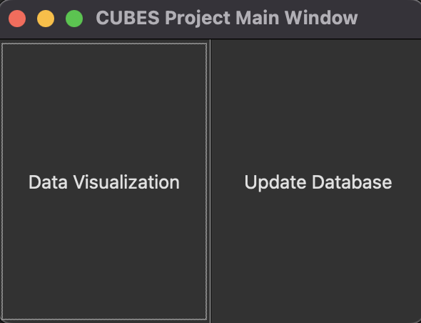

* 1. Data visualization shows the CUBES project entries and their following information. The project can also be claimed from here as well.
  2. **Update Database:** Which is a button that has two outcomes on its pressed action. Either updates the database and tells the user or states there are no new entries to be added to the database (two outcomes shown below).

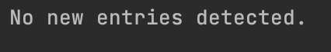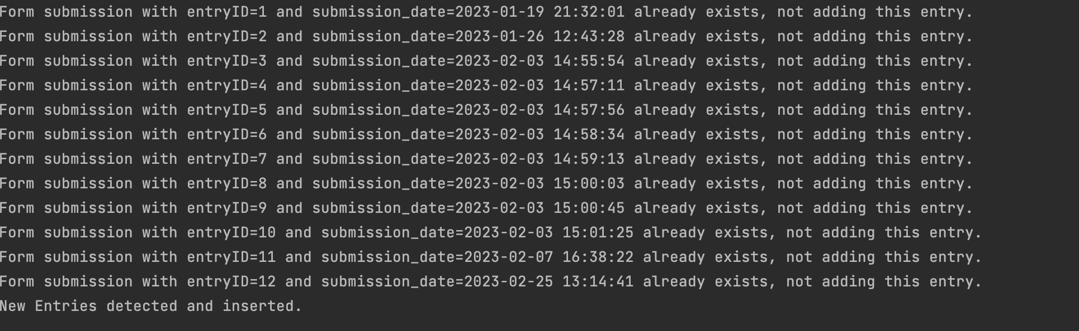

1. **Data visualization:** The main window is as below. There are buttons for each entry in the Wufoo form entry, showing their organization name and their first selected collaborative opportunity.

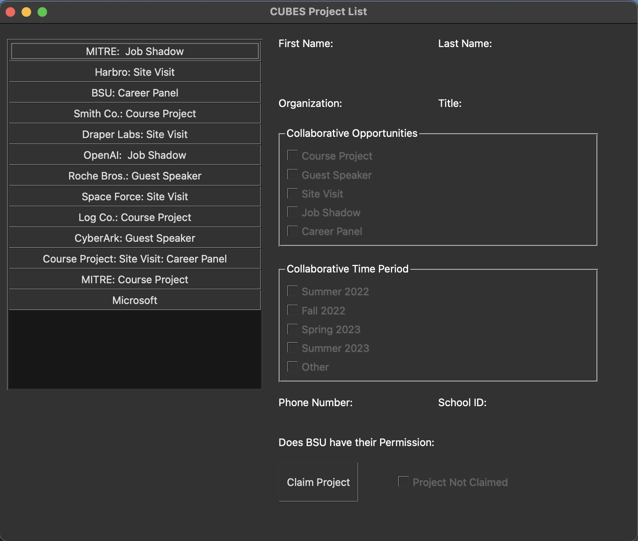

* 1. When a project is selected the corresponding information for the project is shown. The user then has the option to claim a project.

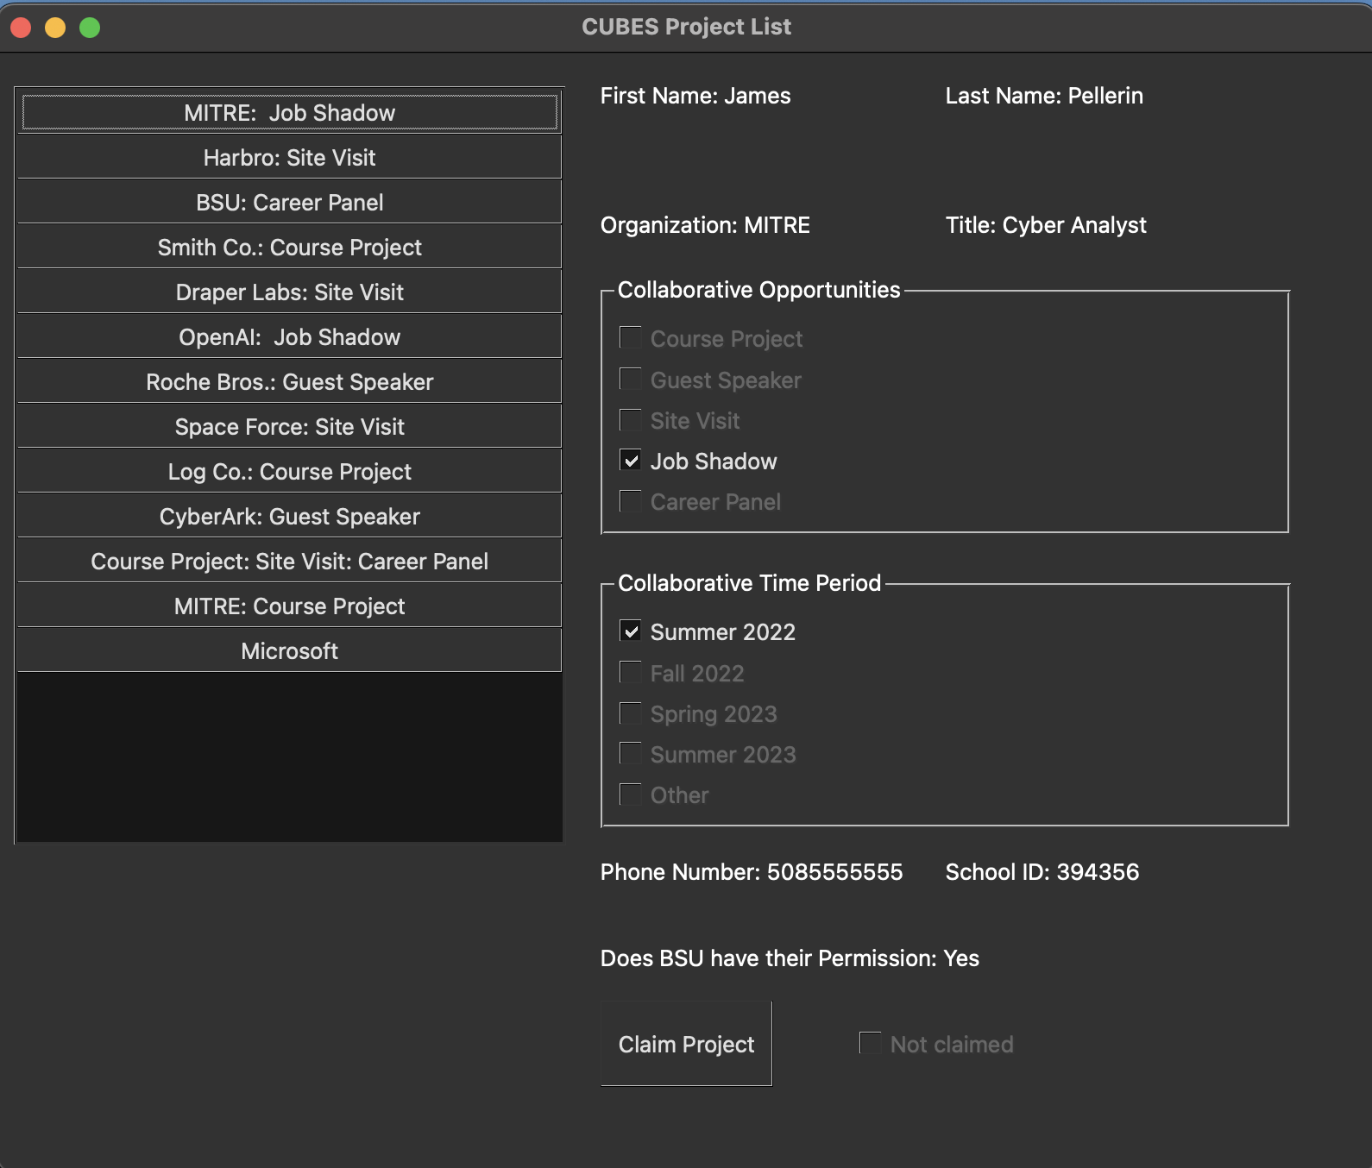

* 1. When the claim button is pressed an entry dialog appears asking the user to enter in their information with a submit button that will attempt to enter their information if there is no duplicate BSU email already that exists. Also, the clear button simply clears the fields in the dialog window. The project button in the list appears yellow only if the user successfully submits their faculty information. If it is successful a message box appears that closes after a short time stating their project was successfully claimed.

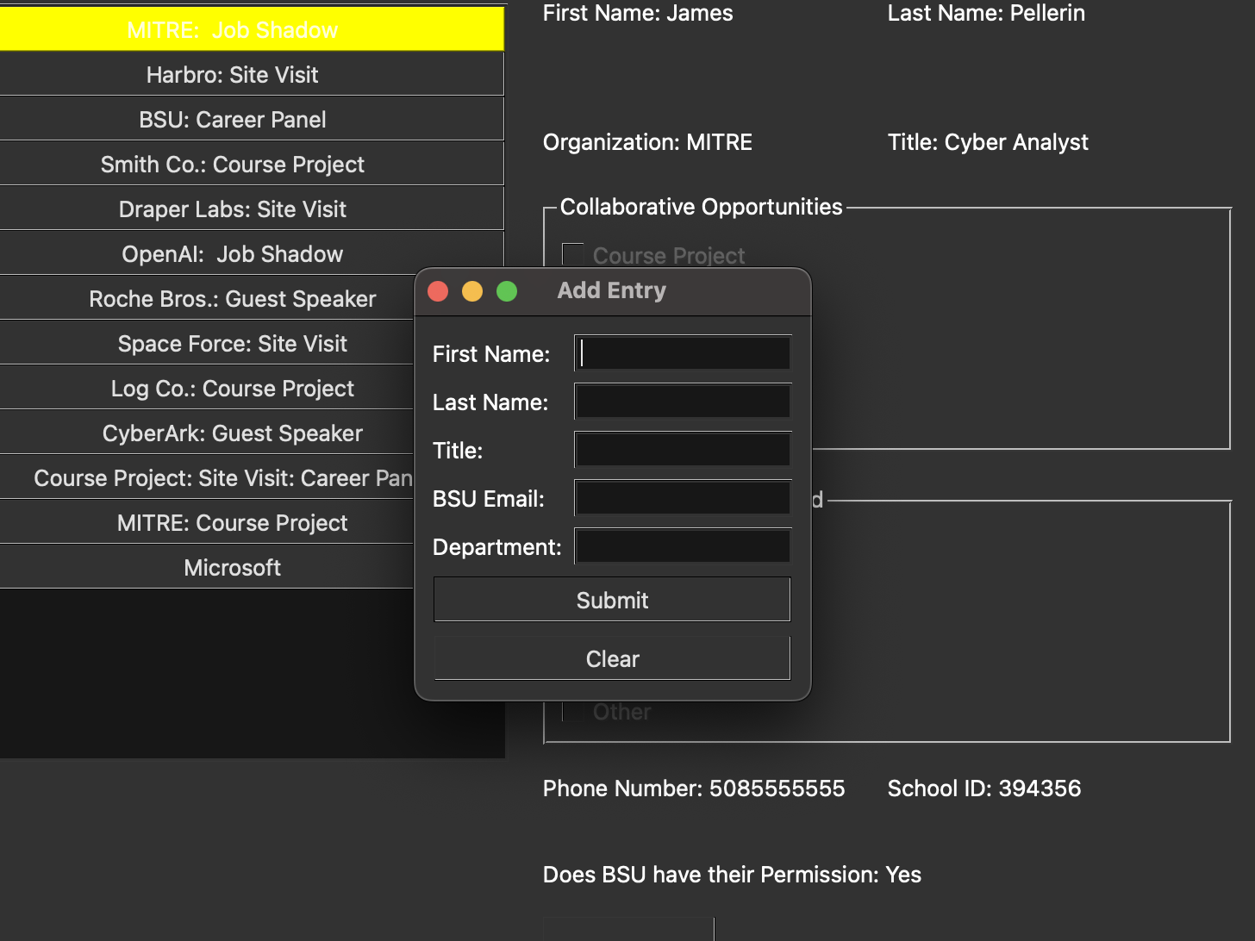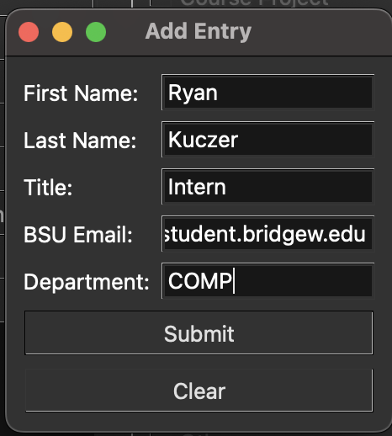

* 1. If the project is successfully claimed, then it is shown by being yellow and a checkbox in the bottom right that states the email of the faculty user that claimed the project. If another user tries to claim the project, it states to the user that the project is already claimed and they cannot enter their information.

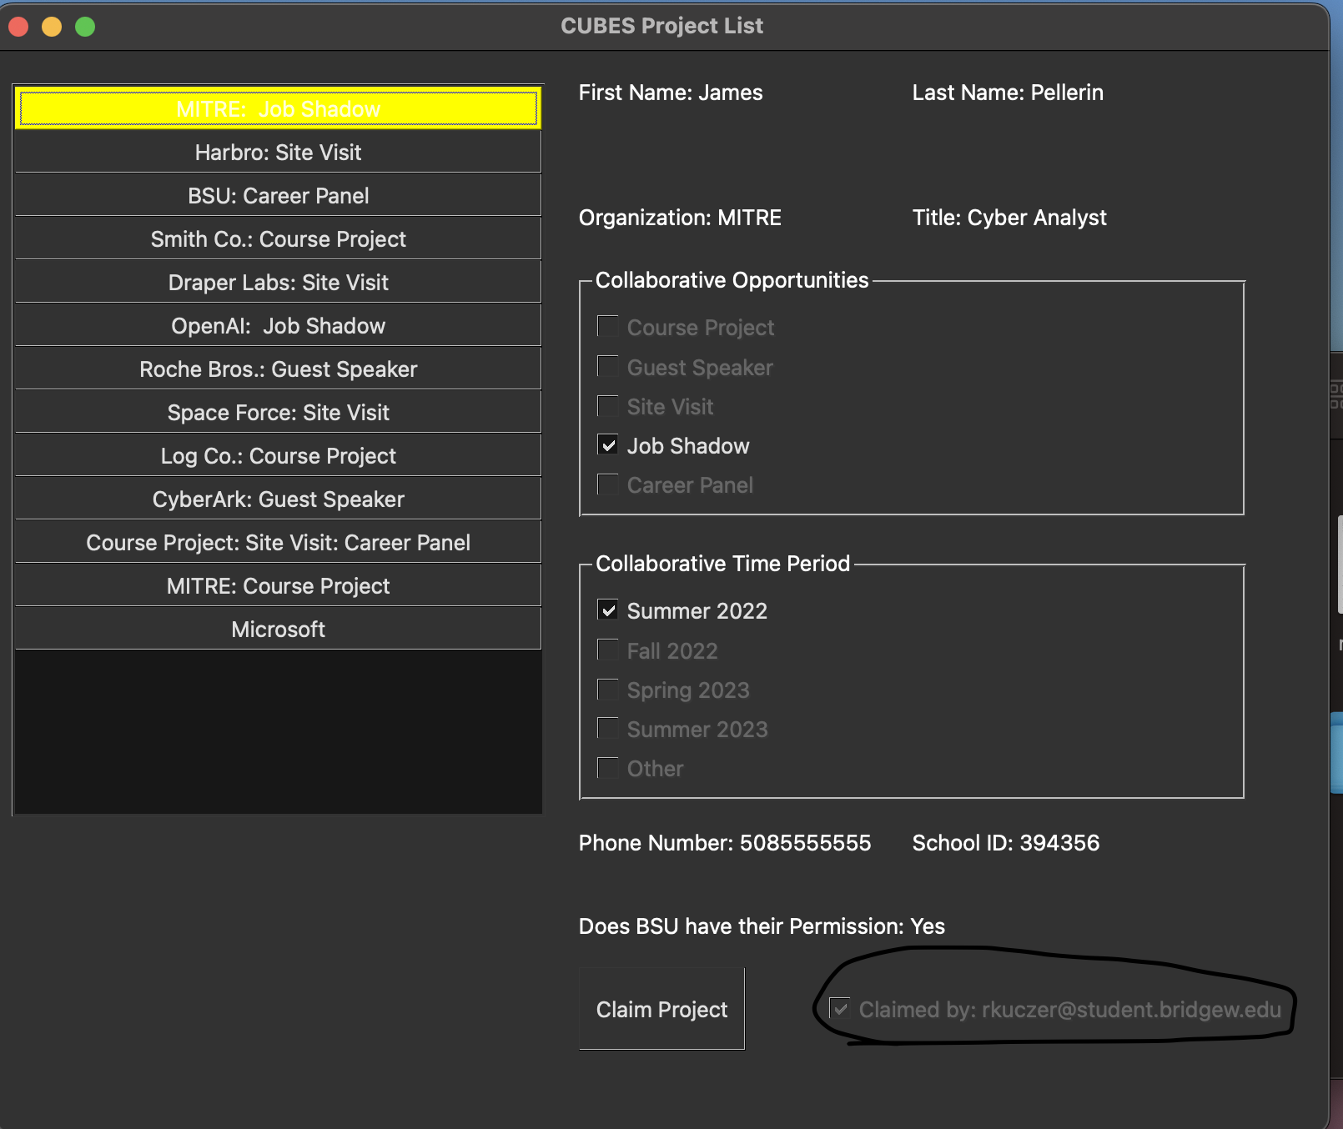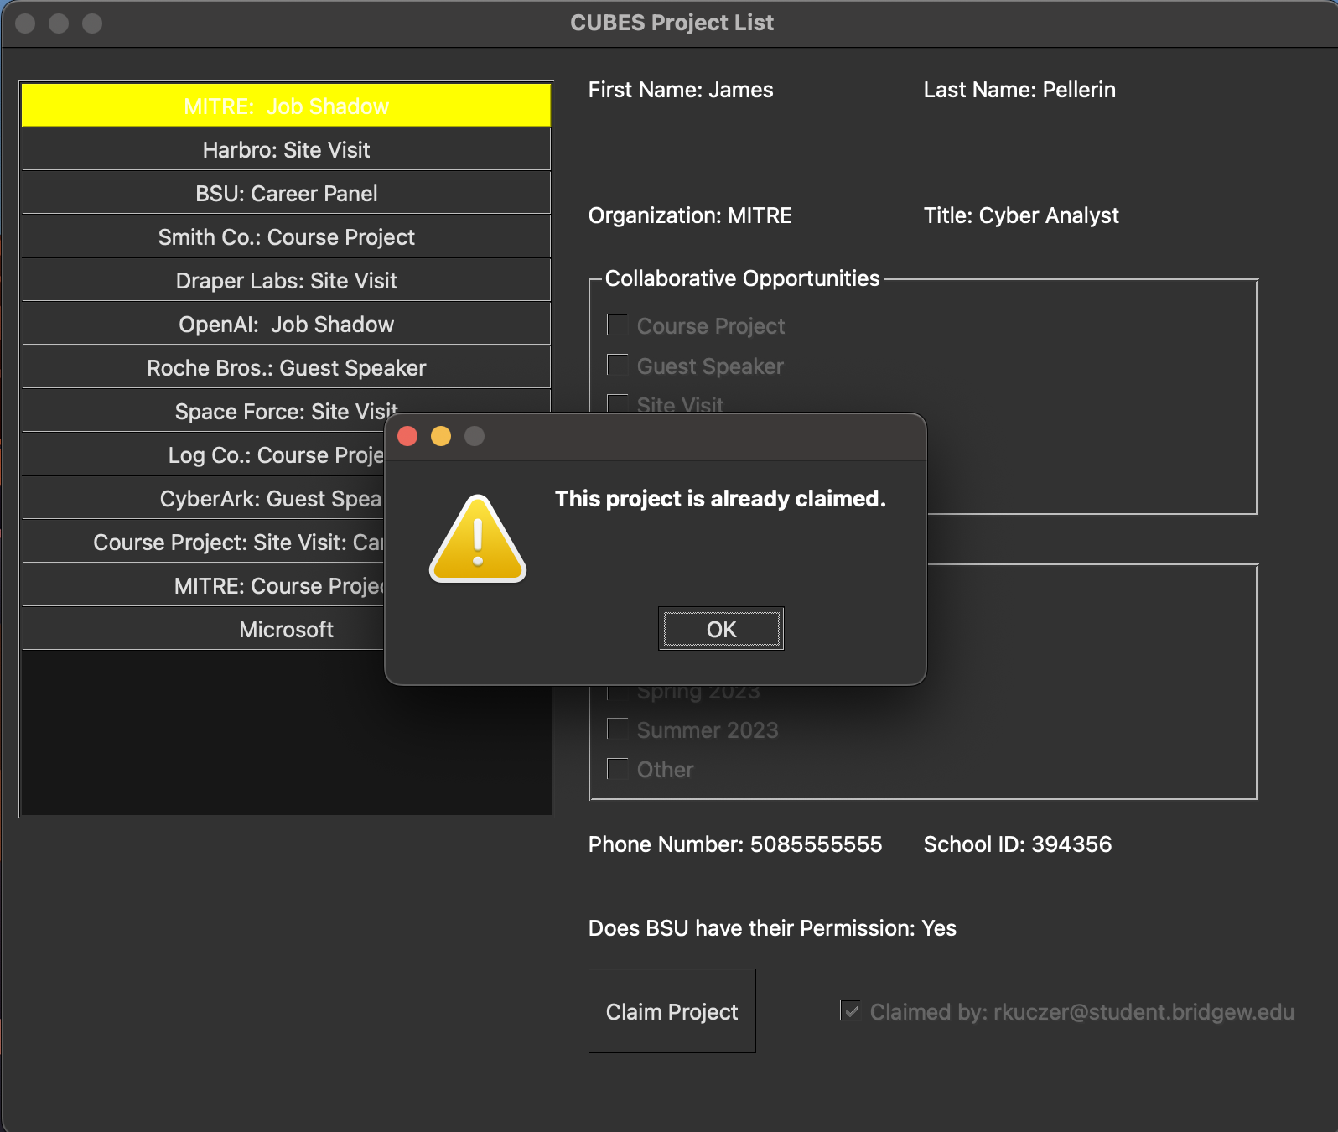

* 1. If the user tries to claim another project with the BSU email that exists already in the faculty records the fields are filled in for them and the project is claimed. Now the user has two projects claimed by them.

